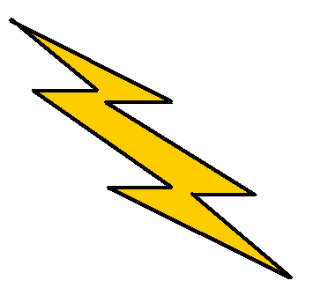Flash Fiction
Flash Fiction is a very short form of fiction—usually between 400-1000 words in total length.
This form of writing helps the writer to focus on plot development and mood.
It may be short but it should also be colorful, and interesting!

Author, Instructor, and Writing Consultant
You may wish to bring a snack and/or covered beverage.
Gloria Nixon-John will share examples of Flash Fiction and guide you through writing prompts so you can create Flash Fiction of your own!
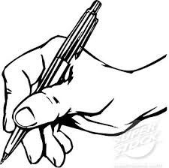

Saturday, March 28th -- 10 A.M. – 1 P.M.
Warren Civic Center Conference Room
Please call to register: 586-574-4564

