Creating a Family History Album
Saturday, May 17, 1 p.m.
Farmington Community Library – Main Branch Auditorium
32737 W. 12 Mile Rd. Farmington Hills, MI 48334

Do you have photographs, clippings, mementos or letters in boxes that you
intend to organize? Or family documents that don’t have a permanent
home?
Learn how to safely create a legacy for your family that will last for
generations. Mitchell Research Center volunteers will show how to safely
organize and display all the memorabilia that families collect over the years.
Albums can be artfully created or utilitarian. Handouts will be provided.

This demonstration is more than scrapbooking - it is part preservation,
part genealogy, and a permanent record of family events.

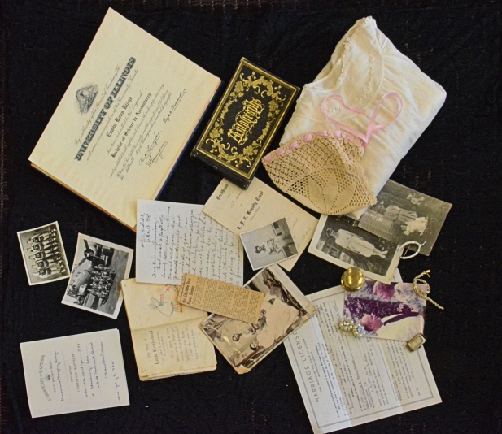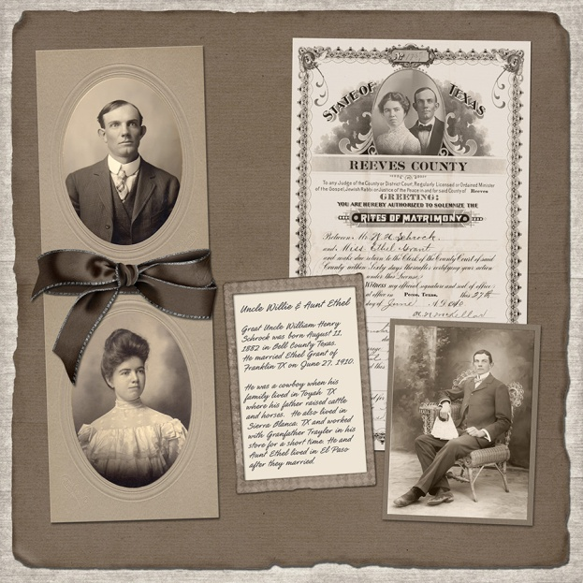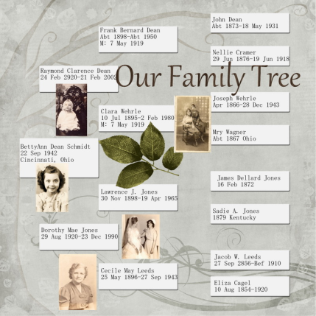

The program is free and open to anyone.
Registration required at www.farmlib.org/events or by calling 248-553-0300.
