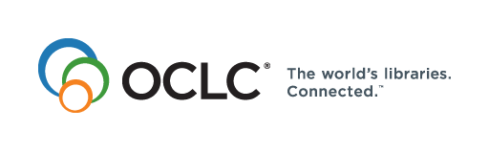
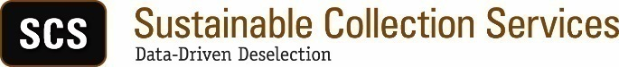

Michigan Shared Print Initiative (MI-SPI)

Project Plan/Refresh Proposal

January 19, 2018

Overview
The Michigan Shared Print Initiative (MI-SPI) developed in the course of SCS’s first group collection analysis projects in 2012-2013. SCS work on that project was completed in late 2013. Given the success of that pioneering project, and the continuing need to manage print book collections collaboratively, MI-SPI repeated and expanded its efforts in 2015.

Building on that success, the MI-SPI group would like to find ways to regain the momentum on shared print initiatives while expanding the group to include additional private colleges. This proposal would refresh the existing data set and extend access for one year. During the next 12 months MI-SPI will lay out the process and pricing model for a full rebuild of the data set with expanded membership.

OCLC/SCS proposes a partial refresh to the current data set. This applies to the current participants and would be limited to the refreshed holdings look-ups, adjusted comparator groups, and removal of weeded items. One comparator group will be reserved for Michigan State University titles that have been transferred to its remote storage facility. These items are in effect committed retentions through 2027, as they have recently been moved to storage, and verified new barcodes have been applied. Although MSU will continue to transfer items over the coming year, this comparator list will only reflect items in storage on the date the data is captured. MSU will work with SCS to produce the necessary list during the planning stage of this refresh project.

Participating Libraries
As in 2015, the contract for MI-SPI will be executed through the Midwest Collaborative for Library Services (MCLS). OCLC/SCS will invoice and be paid by MCLS, which will in turn invoice the participants. Because this is a refresh, no new bibliographic or item data will be needed, and the list of participants will remain the same.

Institution Name | # of monographs | Integrated Library System
Central Michigan University | 558,759 | Ex Libris Alma
Ferris State University | 153,422 | Ex Libris Alma
Grand Valley State University | 292,904 | Innovative Sierra
Michigan-Dearborn, University of | 238,792 | Innovative Sierra
Michigan Technological University | 174,538 | Ex Libris
Northern Michigan University | 280,994 | Ex Libris
Oakland University | 325,296 | Ex Libris Alma
Saginaw Valley State University | 169,899 | Innovative Sierra
Wayne State University | 378,682 | Innovative Serra
TOTAL | 2,573,286

SCS Refresh
The refresh would include the following:
- Complete refresh of the holdings look-ups in WorldCat and HathiTrust
- Adjust and refresh holdings data among comparator groups
- Allow MI-SPI to change comparator groups (if wanted)
- Add Michigan State remote storage items as a new comparator group
- Remove weeded items from the data set
- Extend access for an additional 12 months

Cost Estimate
Pricing for the refresh and extension is 30% of the original price of $136,975 or $41,092.50 and would include an additional year’s worth of access.

$41,092.50 Data Refresh

Payment Terms
OCLC/SCS typically invoices large-scale group projects as follows, though we are open to discussing alternatives.

50% Due at signing ($21,546.25)
50% Due upon completion of the refresh ($21,546.25)

Schedule: OCLC/SCS will be pleased to accommodate the Library’s preferences regarding project schedule, to the highest degree possible. Data work begins upon receipt of a usable data file of deleted items. The Library’s summary data is typically available in GreenGlass within six weeks of that date, depending on the OCLC/SCS production schedule. Scheduling details will be worked out in the initial planning call with the Library.

